**ITI DATA ENGINEER TRACK-GRADUATION PROJECT   
  
STACK OVERFLOW**

**Objective:**

The project's objective is to transform and load Stack Overflow data into a Data Warehouse (DWH) using ETL processes and scheduling. Subsequently, the data will be modeled in SQL Server Analysis Services (SSAS) for analytical insights. The final step involves creating an intuitive Power BI dashboard to visually represent the Stack Overflow data from the years 2008, 2009, and 2010, providing a comprehensive and user-friendly analytics solution.

**Stack Overflow**  
  
Stack Overflow is a popular online community and question-and-answer (Q&A) platform that is focused on programming and technology-related topics. It was created to provide a platform for developers and other tech professionals to ask questions, share knowledge, and collaborate on problem-solving.

**Key features and aspects of Stack Overflow include:**

* **Question and Answer Format:** Users can post questions related to programming, software development, technology, and various other topics. Other users, often with expertise in the relevant areas, can provide answers to these questions.
* **Voting System:** Users can upvote or downvote both questions and answers based on their quality and usefulness. This helps in sorting and highlighting the most helpful and accurate content.
* **User Reputation:** Users earn reputation points for their contributions, such as asking good questions, providing helpful answers, and participating in the community. Higher reputation levels grant additional privileges, such as the ability to edit posts and vote to close or reopen questions.
* **Tags and Categories:** Questions are categorized using tags to make it easier for users to find content related to specific technologies, programming languages, or frameworks.
* **Community Moderation:** The community plays a significant role in moderating and curating content. Users with sufficient reputation can edit posts, close questions, and participate in other moderation activities to maintain the quality of the site.
* **Documentation and Examples:** Stack Overflow not only hosts Q&A but also provides a platform for documentation. Users can contribute to and browse through documentation for various programming languages and technologies.
* **Job Listings:** Stack Overflow also features a job board where companies can post job listings, and users can search for job opportunities based on their skills and preferences.

Overall, Stack Overflow has become a valuable resource for programmers and developers seeking solutions to technical problems, sharing knowledge, and connecting with a global community of like-minded individuals.

**The goal of this phase is to load Stack Overflow posts data into Azure for further analysis using SSIS and SSAS.Data sources include Stack Overflow posts in various formats.**

**Azure Cloud Setup:**

Azure Services Used:

* Azure Storage for storing raw data files.
* Azure SQL Database for structured data storage.

**Step-by-Step Instructions:**

* Create Azure Storage account and containers.
* Configure Azure SQL Database for Stack Overflow data.

**Security Configurations:**

* Set up appropriate access controls for Azure services.

**Data Extraction and Transformation:**

Data Sources:

* Stack Overflow posts data in JSON and CSV formats.

Extraction:

* Utilized Azure Data Factory for extracting data.

**Transformation:**

* Applied transformations using Azure Databricks to clean and format data.

**Loading Data to Azure:**

Method Used:

* Employed Azure Data Factory pipelines for data loading.
* Validation and Monitoring
* Ensured data integrity through Azure Data Factory monitoring.
* Set up alerts for potential issues during data loading.

**Error Handling**

Strategies:

* Implemented retry mechanisms for transient errors.
* Logged errors to Azure Monitor for future analysis.

**Data Sources:**

Our primary data sources consist of the StackOverflow2010 Databases, with destination tables on Azure Cloud named PostTypes, VoteTypes, and LinkTypes. The objective is to establish an efficient ETL pipeline for seamless data transfer.

**Loading Types:**

1. **Initial Load:**
   * The "Initial Load ODS" package is designed to transfer raw data from the sources to the Operational Data Store (ODS), a database on MS Server.
   * No cleaning or transformation operations are performed during the initial load.
2. **Incremental Load:**
   * Following the initial load, our focus shifts to the "Incremental Load ODS" package.
   * This package is responsible for transferring only new or modified rows from the data source to the destination tables.
   * The frequency of implementation is determined by specific schedules, such as every two or three days, aligning with business needs and data source update patterns.

**Target Tables:**

Our analysis revealed that incremental load is crucial for the following four tables due to their size:

* Posts
* Users
* Votes
* Comments

**Incremental Load ODS Package Details:**

**Tables in ODS Database:**

* + Two new tables are created in the ODS Database: Config_table and log_table.
    - **Config_table:** Stores the largest date value for the concerned four tables.

* + - **log_table:** Keeps track of the number of rows entered or modified in the data source.

**Variable Utilization:**

* + Within SSIS, four variables store the MaxLastUpdatedDate values from the Config_table for the four target tables.

**Data Extraction:**

* + Data is extracted from the source with a condition that the row's date is greater than the stored variable date, ensuring retrieval of only new values.

**Lookup and Data Handling:**

* + Lookup is performed between source and destination data based on PrimaryKeys.
  + Unmatched output to the ODS is treated as an inserted row.
  + Matched output is stored in temporary tables (ZZ tables) and considered updated rows.

**SQL Task Execution:**

* + An SQL task is executed to update ODS data using statements within the ZZ tables.

**Configuration and Logging:**

* + Config_table is updated to carry the largest date value for each of the four tables.
  + log_table is populated with data, including the number of rows inserted and updated for each table.

These processes ensure an effective and timely data transfer, with meticulous tracking and management of modifications. Should you have any further inquiries or require additional clarification, please do not hesitate to reach out.  
  
  
**DATA WAREHOUSE:**

Creation Of A Data Warehouse With A Snowflake Schema And The Development Of An SSIS Package For Data Integration And Storage.

**Fact Table: fact_post**

* Description: This table serves as the central repository for post-related information on Stack Overflow.
* Attributes:
  + id (Primary Key): Unique identifier for each post.
  + post_type
  + creation_date
  + answer_count
  + comment_count
  + view_count
  + favourite_count
  + bounty_amount
  + comments_score
  + userid (Foreign Key referencing Dim_User.id)
  + DateK (Foreign Key referencing DimDate.DateSK

**Dimension Tables:**

* **dim_date**
* Attributes:
  + date_id (Primary Key): Unique identifier for each date.

Date-related information such as day, month, year.

Additional Information: Useful for time-related analysis.

* **dim_user**
* Attributes:
  + user_id (Primary Key): Unique identifier for each user.
  + creation_date
  + DisplayName
  + location
  + DownVotes
  + UpVotes
  + Reputation
  + Views
* **dim_tags**
* Attributes:
  + tag_id (Primary Key): Unique identifier for each tag.
  + post_id (Foreign Key referencing Fact_Post.id)
  + tags
* **dim_comments**
* Attributes:
  + comment_id (Primary Key): Unique identifier for each comment.
  + creation_date
  + comment_userid
  + post_id (Foreign Key referencing Fact_Post.id)
* **dim_votes**
* Attributes:
  + vote_id (Primary Key): Unique identifier for each vote.
  + creation_date
  + vote_type
  + post_id (Foreign Key referencing Fact_Post.id)

**SSIS Package Development:**

**Data Integration and Transformation:**

* Develop an SSIS package to extract data from the Operational Data Store (ODS).
* Implement necessary transformations based on business rules and requirements.
* Load the transformed data into the SQL Server data warehouse.

**Staging Layer:**

* Create a staging layer in the SSIS package to temporarily store the transformed data before loading it into the data warehouse.
* This layer helps in validating and ensuring data quality before permanent storage.

**Backup and Azure Blob Storage:**

* Integrate a step in the SSIS package to take a backup of the output data.
* Upload the backup into Azure Blob Storage for additional data redundancy and disaster recovery.

**SSIS Package Development (Extended)**

**Scheduling the Packages:**

* Once the SSIS package is developed for data integration, transformation, and storage, it is crucial to schedule its execution for regular and automated processing.
* Use SQL Server Agent or another scheduling tool to set up a recurring job for running the SSIS package at specified intervals, ensuring that the data warehouse stays up-to-date.
* Consider the business requirements and data refresh frequency to determine the appropriate scheduling frequency (e.g., daily, weekly, or monthly).
* Configure logging and notifications within the SSIS package to receive alerts in case of any issues during execution.
* Monitor the execution logs regularly to ensure that the SSIS package runs successfully and troubleshoot any issues promptly.
* Adjust the schedule as needed based on changing business needs, data volume, and performance considerations.

By incorporating scheduling into the SSIS package development process, you establish a systematic and automated approach to keep your data warehouse consistently updated and aligned with the operational data store. Regular scheduling ensures that the ETL (Extract, Transform, Load) process becomes an integral part of your data management strategy, providing timely and accurate data for analytical purposes.

**Conclusion:**

This part outlines the key steps involved in your project, from designing the data warehouse with a snowflake schema to implementing an SSIS package for data integration, transformation, and storage. It emphasizes the importance of a well-organized structure for both fact and dimension tables, along with the inclusion of a staging layer and Azure Blob Storage for backup purposes.

**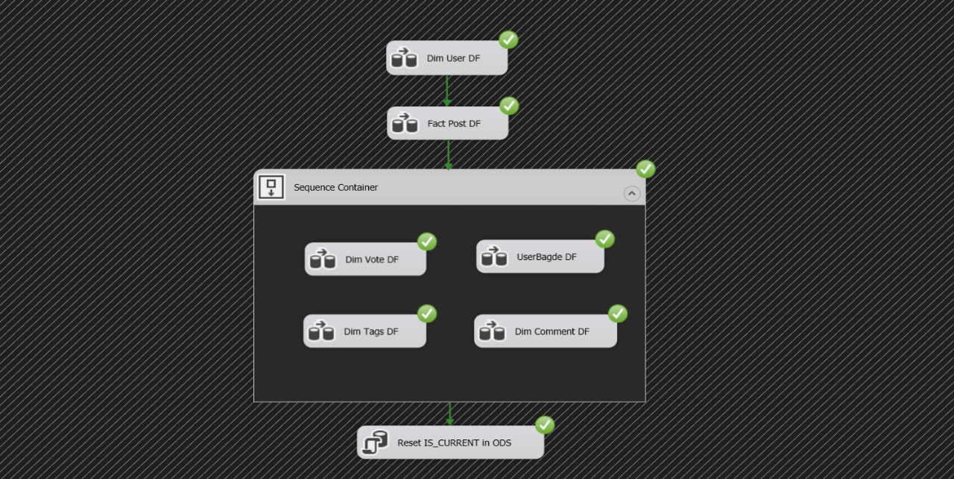  
  
  
  
SSAS Analytics Documentation:**

**Introduction**

* This phase focuses on leveraging SQL Server Analysis Services (SSAS) for analytics on Stack Overflow posts data loaded from the data warehouse.

**Data Model in SSAS**

Structure:

* SSAS cube named "StackOverflowCube" designed with dimensions (e.g., Time, Users) and measures (e.g., Post Count).

Hierarchies:

* Time dimension hierarchy includes Year, Month, and Day.

**Cube Processing:**

Processing Steps:

* Full processing of the SSAS cube scheduled regularly.
* Incremental processing for efficiency during regular updates.

Optimizations:

* Aggregations defined to enhance query performance.

**MDX Queries:**

Example Queries:

* Retrieve total post count: SELECT [Measures].[Post Count] ON COLUMNS FROM [StackOverflowCube]
* Analyze posts by month: SELECT [Measures].[Post Count] ON COLUMNS, [Time].[Month].Members ON ROWS FROM [StackOverflowCube]

Insights:

* MDX queries used to derive insights into Stack Overflow posts data.

**Integration with Other Tools:**

Integration Points:

* SSAS integrated with Power BI for interactive reporting.

Documentation for End Users:

* Access and Interpretation
* End-user guide provided for accessing SSAS analytics through tools like Power BI.
* Documentation on interpreting SSAS cube dimensions and measures.

**Dashboard Overview:**

The Power BI dashboard has been crafted to deliver a straightforward visualization of key insights from Stack Overflow data across the specified years (2008 - 2010). The aim is to enable team members to easily derive meaningful information and trends.

**Key Visualizations:**

**Temporal User Trends:** Line graphs depicting trends in user activities, including metrics such as user registrations, question postings, and answer submissions across the three years.

**Top Budgets and Tags:** Bar charts showcasing the most prevalent tags or categories of questions asked within the Stack Overflow platform during the specified years.

**User Demographics:** Pie charts or graphs displaying demographic information like age groups, gender distribution, or other user-related statistics.

**Conclusion:**

The Power BI dashboard created for analyzing Stack Overflow data from 2008 to 2010 offers a simplified yet comprehensive view of user engagement, and key trends. The focus on simplicity ensures that all team members can easily extract insights and make informed decisions based on the presented data.

